Login URL :
AI Coding Workspace || http://localhost:5173/

Step1: UI Design of Application

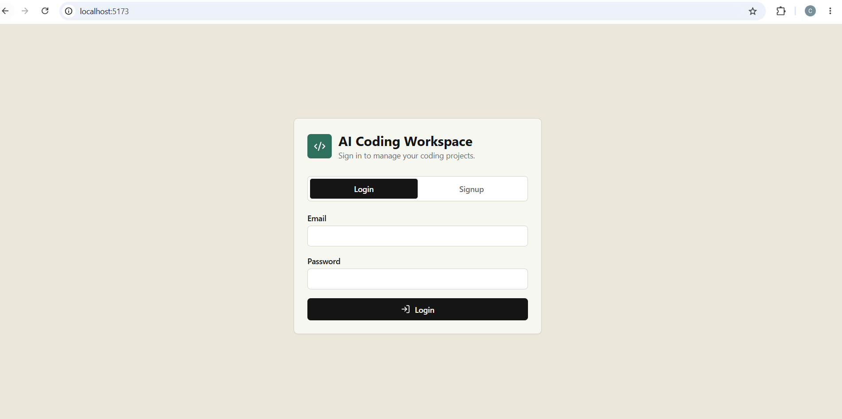

Step2: Signup page
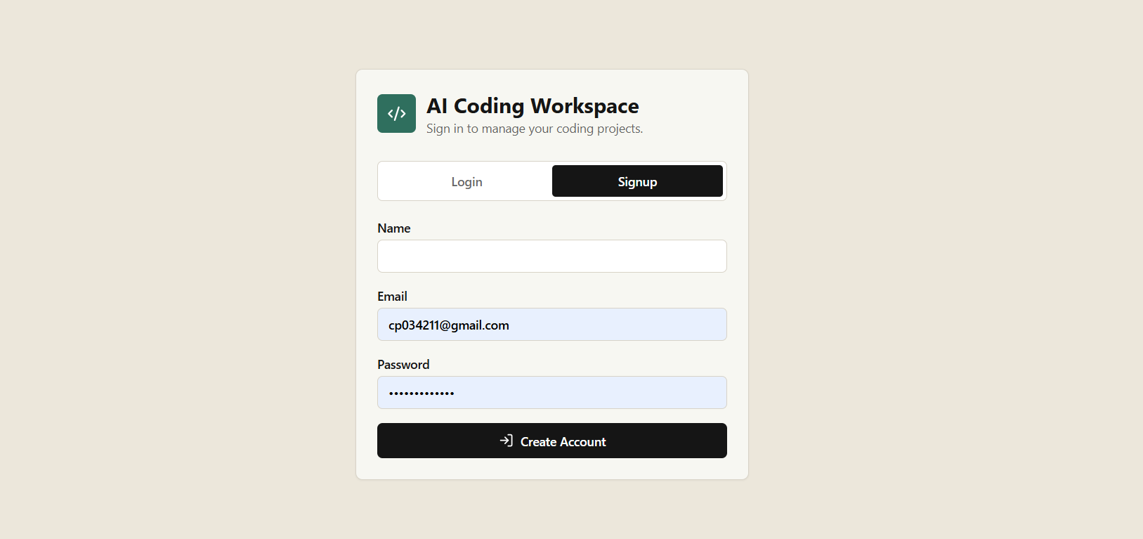

Step3: Workspace of AI coding
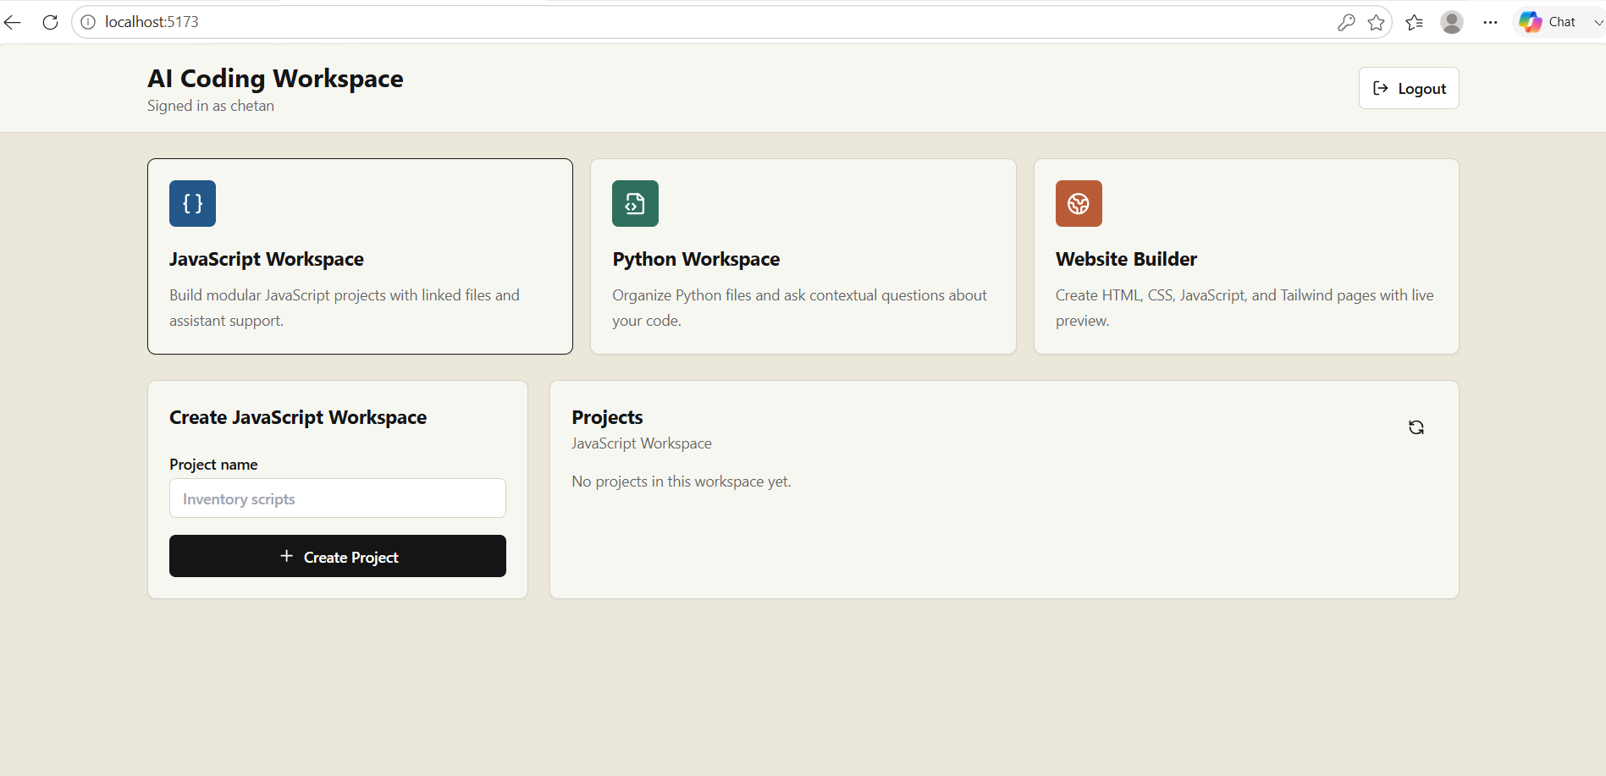

Step4 : Testing task:

